Project Design Phase-II
Technology Stack (Architecture & Stack)
Technical Architecture:
The Deliverable shall include the architectural diagram as below and the information as per the table1 & table 2
Example: Order processing during pandemics for offline mode
Reference: https://developer.ibm.com/patterns/ai-powered-backend-system-for-order-processing-during-pandemics/
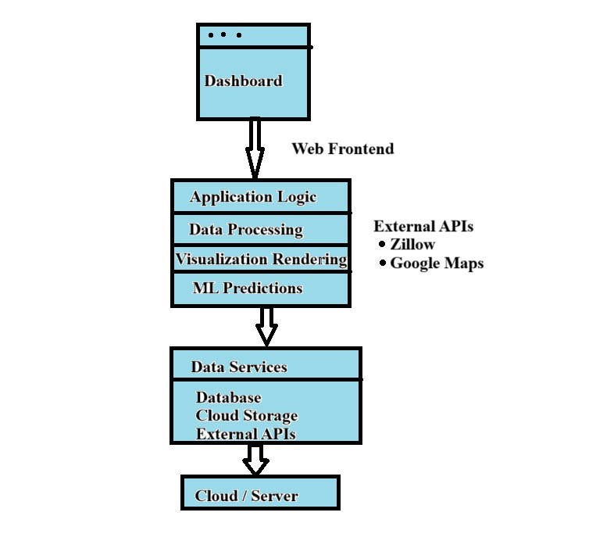

Table-1 : Components & Technologies:
S.No | Component | Description | Technology
1. | User Interface | Web-based dashboard for data visualization | HTML, CSS, JavaScript, React.js  / Angular
2. | Application Logic-1 | Data preprocessing, aggregation | Python (Pandas, NumPy)
3. | Application Logic-2 | Visualization generation & rendering logic | Tableau / D3.js / Plotly
4. | Application Logic-3 | Machine Learning model for price prediction (if any) | Python (scikit-learn, XGBoost)
5. | Database | Store housing data (price, location, features) | MySQL / PostgreSQL
6. | Cloud Database | Scalable hosted database | AWS RDS / Firebase / Google Cloud SQL
7. | File Storage | Store raw datasets and files | AWS S3 / Google Cloud Storage / Local storage
8. | External API-1 | Get real-time housing or pricing data | Zillow API / RapidAPI Real Estate APIs
9. | External API-2 | Geolocation & mapping integration | Google Maps API
10. | Machine Learning Model | Predict housing prices based on features | Trained regression model in Python
11. | Infrastructure (Server / Cloud) | Deployment of app on cloud or local | Local server / Heroku / AWS / GCP /  Docker

Table-2: Application Characteristics:
S.No | Characteristics | Description | Technology
1. | Open-Source Frameworks | Frontend & backend frameworks | React.js, Flask, Django, Pandas, scikitlearn
2. | Security Implementations | Access controls, user authentication | JWT, OAuth2.0, HTTPS, Role-based Access
3. | Scalable Architecture | Use of microservices for backend and visualization layers | Docker, REST APIs, Kubernetes  (optional)
4. | Availability | Deployed on scalable cloud platforms, load balancing via reverse proxy (if applicable) | AWS Load Balancer, Nginx
5. | Performance | Caching frequently accessed data, using optimized queries | Redis, CDN, Indexed DB Queries

References:
https://c4model.com/ https://developer.ibm.com/patterns/online-order-processing-system-during-pandemic/ https://www.ibm.com/cloud/architecture https://aws.amazon.com/architecture https://medium.com/the-internal-startup/how-to-draw-useful-technical-architecture-diagrams-2d20c9fda90d

